Farmer Expenses, Harvest and Profit Analyzer for Rice and Vegetables In Pakil, Laguna

A Final Project
Presented to the Faculty of
College of Information Technology Education
World Citi Colleges - Antipolo City

In partial fulfillment
of the requirements for IT 105
Integrative Programming 2

By:
Abujen, Ed Gabariel
Babadilla, Dwight Neil D.
Duque, Jan Rei N.
Jaen, Dharwin C.
Macaraig, Aaron Jay
Russell, Justine Carl F.

May 2026

TABLE OF CONTENTS

Title Page.…………………….………………………………………...……………..…..…..…I
Chapter I – THE RESEARCH PROBLEM
1.1 Introduction.…………………………………………………………..….……...…
1.2 Statement of the Problem…………………………………………..…….……....
1.3 Objective of the Study…………………………………………….…….…..….....
Chapter II – RESULT
2.1 System Features ………….……………………………..…………....………….
2.2 System Modules .…………………………..…………………….………………
Chapter III – RESEARCHER PROFILE
3.1 Researcher profile ….……………………….……………….………………..…
3.2 Photo Documentation………………………………………………………...…..
CHAPTER I
INTRODUCTION
The agriculture is a crucial sector in the Philippines as it brings food to the tables and income to most Filipino families. In the countryside such as Pakil, Laguna rice and vegetables are the main livelihood of local residents. There is so much farmers do in every planting season that how much time, how much work, and how much money it is devoted to a successful harvest. land preparation, planting, irrigation, fertilization, pest control, harvesting and transportation are farm activities that need to be sufficiently budgeted for and financially managed. Because of this reason, it is highly essential to know the profitability of the farm business by keeping a tab on all farm expenditures and income from the farm produce
‎ However, using notebooks and pens, handwritten lists, or memorizing the numbers when recording their expenses and sales are the traditional approaches that most farmers still rely on. These are usually chaotic, partial and with mistakes. Some records may be lost or destroyed while others may be out of date through the process of time. They might not be able to calculate their overall expenditure, income and profit or loss ( after each and every harvest season) It will undoubtedly make it difficult for farmers to evaluate the success of their farm and make sound financial decisions regarding future growing seasons.
‎As a result, they may have difficulty assessing how well they are doing in their farming efforts and making good financial decisions for future crop cycles. The technology influence is seen in many areas of working and farming lives among them agriculture. With the help of a computerization system, users can better organize data, eliminate human errors, save time and get more reliable results. Financial monitoring in farming A financial monitoring system can help farmers keep track, more easily and reliably, of farm-related transactions. Calculations can be made more quickly via automation and reports can be easily produced. This may allow farmers to have a better understanding of the financial status of their farm operations and to see where they could possibly cut costs or make more money.‎
‎The proposed research work is concentrated on the designing of a system that would record farm expenditures and harvest details of rice and vegetable farmers in Baras, Rizal. Users will also be able to add to their expenses fertilizer cost, labor cost, seeds, pesticides and anything else they use in farming. It will also allow farmers to add harvest information such as crop type, harvest yield and reaching price per kg. Using the information provided, the system will calculate the total cost, the total revenue and the net profit or loss for each crop cycle automatically. Furthermore, summary reports can be produced and records can be stored for later use.
‎The system to be designed in this research would be advantageous not only to the farmers but also to the students and prospective researchers. The system can enhance the ability of farmers to manage their finances and make decisions and can serve as a source of reference for students and researchers for more advanced agricultural or financial monitoring systems in the future. By introducing a more systematic and computerized approach, the study intends to contribute to the enhancement of farm record keeping and the promotion of good farming particularly in the community of Baras, Rizal.
STATEMENT OF THE PROBLEM
GENERAL STATEMENT OF THE PROBLEM
The lack of a centralized, systematic method for tracking expenses and monitoring crop cycles makes it difficult for small-scale traditional farmers to accurately assess their financial performance. This reliance on manual memory and unstable market factors often results in operational inefficiencies, uncalculated financial losses, and difficulty in planning future crop production.
SPECIFIC STATEMENT OF THE PROBLEM
- How to design a system with a user-friendly interface tailored to elderly or traditional farmers that displays pre-defined agricultural checklists and digital budgeting forms?
- How can a digital farm management system help small-scale farmers track fast-changing, high-frequency maintenance costs like fuel (diesel) and agricultural inputs in a more structured manner?
- How will the application compute and evaluate seasonal profit or loss by comparing recurring capital expenses against volatile market pricing during active four-day harvest cycles?
- How will the farmer utilize the historical crop cycle data to determine the optimal timing for land preparation and crop rotation?

OBJECTIVES OF THE STUDY
The study aims to develop and assess a Farm Data Analyzer and Reporting System that uses automated inventory checklists and visual financial tracking to enrich farm management for small-scale ampalaya (bitter melon) farmers in Pakil, Laguna. It evaluates the system effectiveness in enhancing expense transparency, budget planning accuracy, and user satisfaction among traditional farmers. By addressing these issues, the application seeks to improve operational efficiency and financial sustainability at the farm level.

SPECIFIC OBJECTIVES
- To design and develop an intuitive system equipped with a pre-defined agricultural checklist and budgeting forms tailored to the user capabilities of traditional or elderly farmers.
- To implement a structured data-logging system within the application that records high-frequency, fluctuating operational expenses such as fuel (diesel), insecticides, and fertilizers.
- To create an automated financial evaluation tool* that calculates real-time profit and loss margins by cross-referencing multi-day harvest yields (per kilogram) against active market pricing.

CHAPTER II
RESULT
2.1 System Features
1. Automatic Database Setup
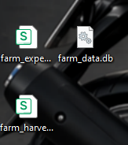
Every time you open the program, it automatically checks for, and then sets up its database files , like it does it on its own. You don’t really need to install any extra software, so your records stay kept without any hassle.
2. Expense Recorder
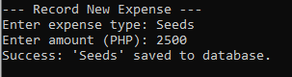
This feature helps you jot down where the money goes, like buying fertilizer, paying for labor, or picking up fuel.
Smart Date tracking : the system automatically notes the exact day you put the expense in.
Typing protection : if you happen to write letters where a number should be for the cost, the program will politely warn you, not just stop and crash.
3. Harvest Recorder
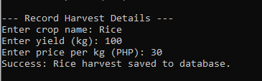
This feature kinda keeps track of what the farm produces, and also what it sells. You just type in the crop name, the amount in kilograms you harvested ,and the selling price per kilo. It works in a similar way to the expense recorder, it logs the date right away and double checks you enter numbers that are actually valid.
4. Detailed Summary Report
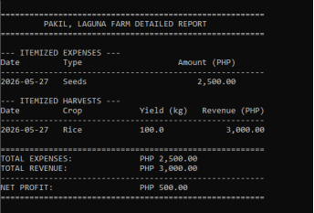
This feature kind of instantly figures out how the farm is going money-wise. With one click it reads your stored data and then shows you an organized, kinda side by side list of every past expense plus your harvest results.
Total Revenue: the full amount of money you got from harvests.
Net Profit or Loss: it takes your total expenses and subtracts them from your total earnings. If you earned more, it will label it NET PROFIT. If you ended up spending beyond what you made, it automatically switches the wording to NET LOSS.
5. Export to Excel (CSV)
This feature kind of takes all of the data in your program and turns it into two spreadsheet files : farm_expenses.csv and farm_harvests.csv. You can open those files in Microsoft Excel or Google Sheets , so you can print them, create graphs, or simply keep them as a backup .

2.2 System Modules
Below are the main modules of the Pakil, Laguna Farm Analyzer System with screenshot and explanation of each part.
1. Main Menu:
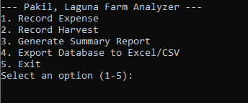
This is the Main Menu of the system. It displays the list of available function that the users can choose from:
1 - Record Expenses
2 - Record Harvest
3 - Generate Summary Report
4 - Export Database to Excel/CSV
5 - Exit
Select an option (1-5):
If name main: is the entrance of the program. This code block ensures that the main_menu() function will only execute if the file is executed directly by Python.
2.Record Expenses Module:

The add_expense() function allows for adding new information regarding expenses made in the farm. Users should provide the name of the expense category and its value, while the date will be added automatically. Information provided will be inserted in the expenses table within the database. This function contains error prevention options. This function records information regarding harvested crops. Users provide the name of the crop that has been harvested, harvest weight in kilograms, and its price per kilogram. All this information along with the current date will be recorded in the harvests table.
3.Record Harvest Module:

This module records harvest information. The user inputs the crop name and yield in kg and price per kg. After saving a confirmation will appear. And the information will automatically save in the database.
4. Generate Summary Report Module
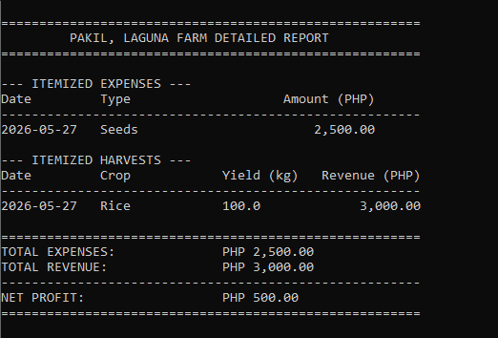
This module generates the summary report. It shows:
-Itemized Expense
-Itemized Harvest
-Total Expenses
-Total Harvest
-Net profit or loss
The report generation function will enable the users to assess the financial status of the farm and determine its profit or loss situation.
5.Export Databased to CSV module
This module exports the data from the database into two CSV files.
- farm_expenses.csv
- farm_harvest.csv
These files can be opened to Microsoft Excel or any spreadsheet application.
6. Exit Module
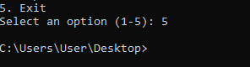
This module closes the system and ends the program.

CHAPTER III
RESEARCHER PROFILE
3.1 Member’s profile
  
Jaen, Dharwin C. Russell, Justine Carl F. Duque, Jan Rei N.
Programmer / Documentation Documentation Documentation
  
Macaraig, Aaron Jay Abujen, Ed Gabariel Babadilla, Dwight Neil D.
Documentation Documentation Documentation
3.2 Photo Documentation
